DYNAMIC PIT STOP
Integrated C4C Plates (Plain or Stripe Style) $20 each
Name (First/ Last):
Email: . Phone:
What car club are you a member of:

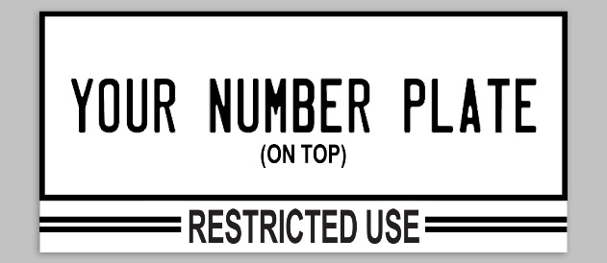
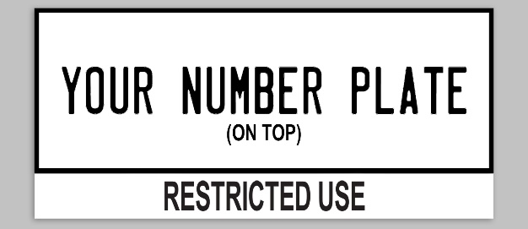
WHAT STYLE WOULD YOU LIKE:

 PLAIN  STRIPE

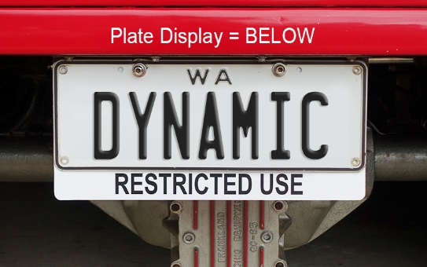
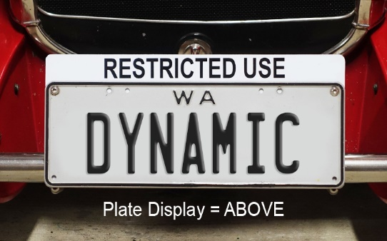
ABOVE OR BELOW PLATE DISPLAY:

 ABOVE: QTY _____  BELOW: QTY_____

WHAT IS THE LENGTH X HEIGHT OF YOUR LICENSE PLATE (mm):  STANDARD (370x130mm)
CUSTOM: _

POSTAGE DETAILS:
 PLEASE POST TO THE BELOW ADDRESS = + $8.00 flat rate

Postage Address: ________ ____
Suburb: _____________________________ Post Code: _______________
Please email the completed form to pitstop@dynamicstyle.com.au
Once we have received your completed form, we will contact you within 2 business days to take card payment over the phone.
Total: $______________ Paid:  Posted: 

